Suspend Broadband and Voice Service Over Cable

Version Control:

Use Case Name: |  | Suspend Broadband and Voice Service
Use Case Owner: |  | Sumit Borade
Current Version |  | 0.3
Use Case Version History
Modified Date | Version |  | Modified By | Change Description
June 28, 2009 | 0.1 |  | Tom Schnarr | Initial Version
July 8, 2009 | 0.2 |  | Tom Schnarr | Expanded from Suspend Broadband Service to include Voice
August 26,2009 | 0.3 |  | Sumit Borade | Updates to add Reply steps
October 28 | 0.4 |  | Sumit Borade | Updated the Description of the Steps

Brief Description:
This use case describes the process by which a YouSee subscriber’s broadband service is suspended. The subscriber may also have voice services in which case the voice services are also suspended.

The use case is written from the perspective of the SMP provisioning solution.

Related Documents
- YouSee SMP SOW2Architecture Requirements Document
- YouSee SMP SOW2 Business Requirements Document
- Voice over Cable Use Case Activation
- Cisco BACC TC Specification
- Cisco BTS TC Specification

Related Use Cases

Pre-Conditions
- Subscriber is an active broadband and optional Voice over cable subscriber.

Post-Conditions
- Subscriber’s service has been suspended and he can no longer access Broadband services and optional Voice Services unless the resume use case is processed.

Use Case

Primary Flow Diagram
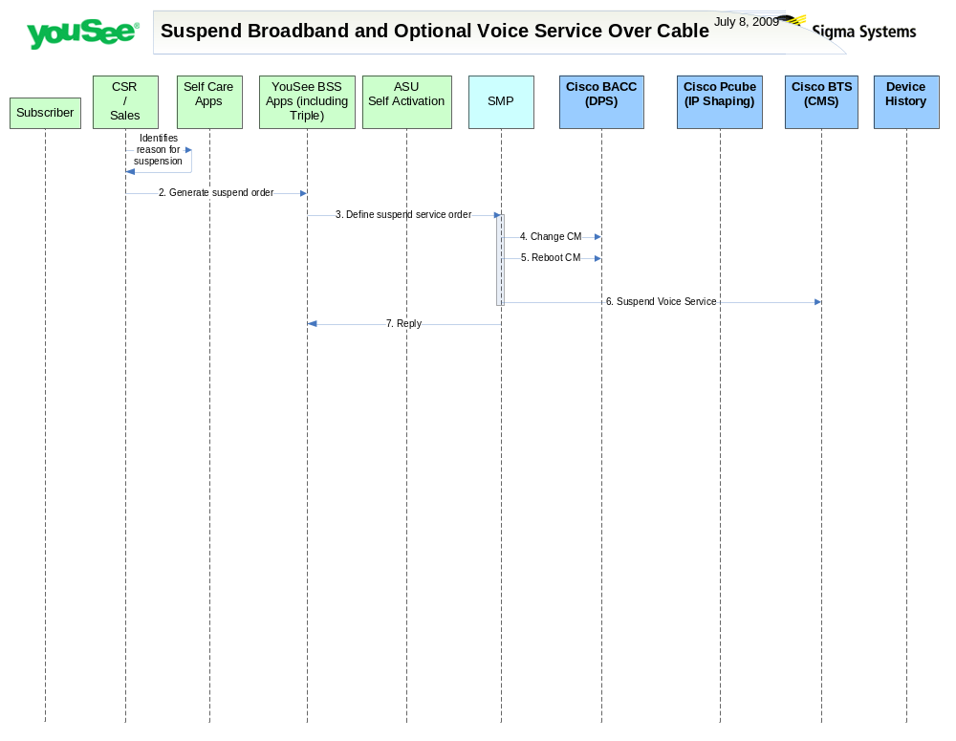

Primary Flow Detail
# | Actor: Key Action | Description | Alternate Flows/Details
 | CSR: Identifies reason to suspend subscriber’s broadband service | A YouSee employee or business process identifies a reason to suspend a subscriber’s broadband service. This may be due to a non-pay scenario, extended vacation or other non-compliance reasons which are out of the scope of this document
 | CSR: Order is created in YouSee BSS applications | The Customer Service Representative defines the order in YouSee BSS Applications (Triple)
 | YouSee BSS: Order is communicated to SMP | <As in Change service Order>
 | SMP: modifies CM in BACC | SMP will change the configuration of the CM in BACC resulting in blocking of Broadband traffic. If the Subscriber has Broadband and Voice Service then suspending Broadband Service on CISCO BACC will result in blocking of Voice Service as well.  For suspending Broadband SMP will change the Broadband Product with a New Product to have no data Traffic.
 | SMP: requests BACC to reboot the CM Device | Device is rebooted resulting in it receiving the new configuration
 | SMP: suspends voice service in Cisco BTS | If the subscriber is entitled to Voice service, the voice service is also marked as suspended in the BTS.  For suspending Voice Service on CISCO BTS SMP needs to change the cos-restrict-id on CISCO BTS to “1”.
 | SMP: Replies back to Triple the status of Activation | SMP will reply to ASU the status of Provisioning Order to ASU. | If Provisioning fails then SMP will put the Failed task in Manual Queue.

